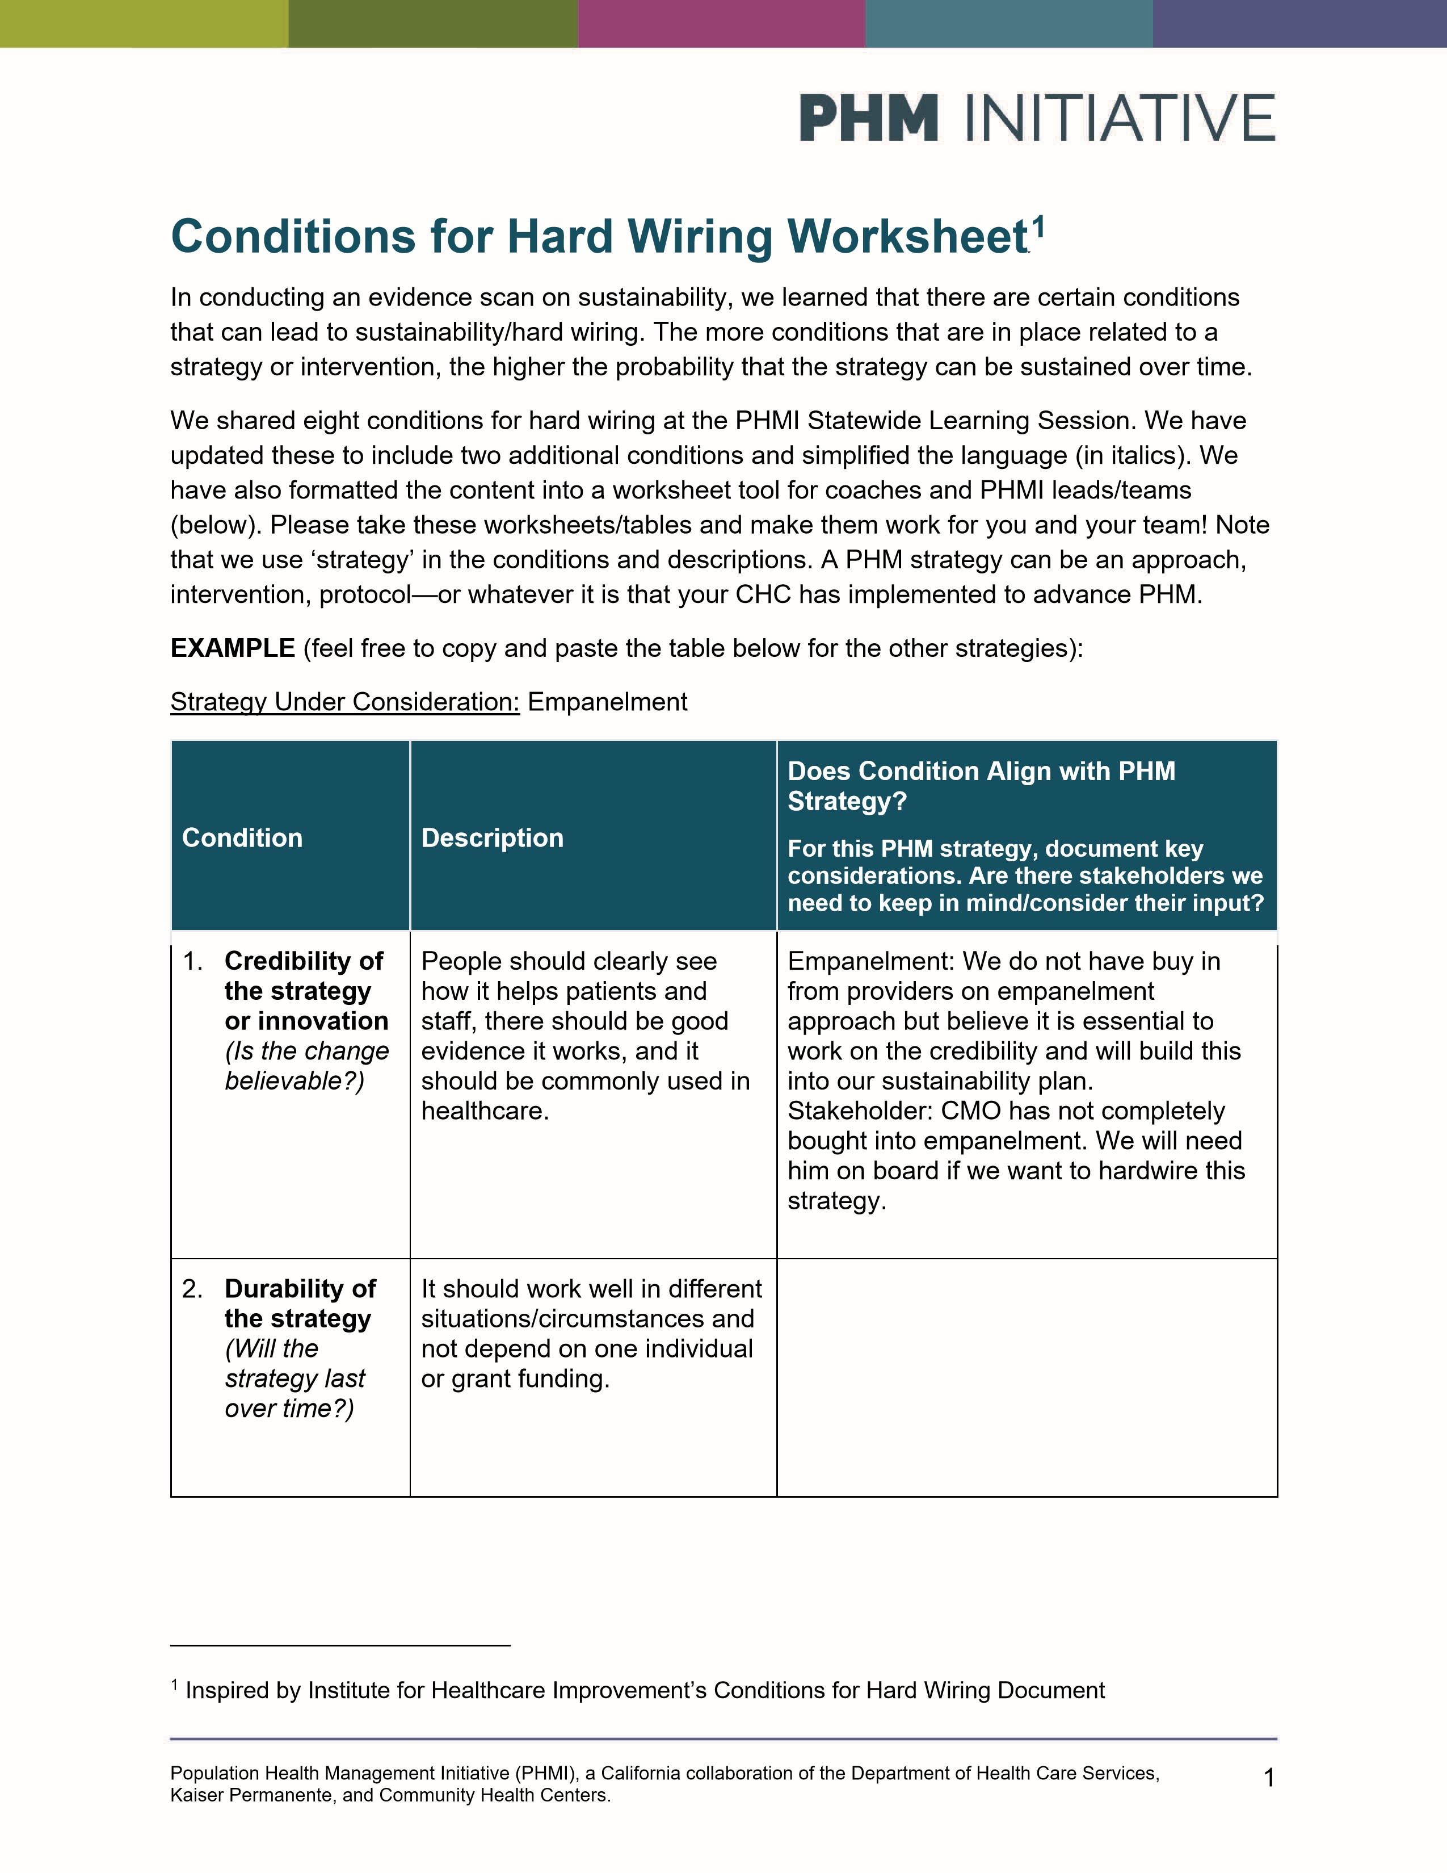
3. Goal  specificity  (is there an established clear goal associated with the strategy?) | There should be a specific target, like a certain measurement, that the change is supposed to improve and that you can track over time.
4. Fit with organization  (does it fit with our  organization?) | The strategy should match our organization’s strategic priorities, goals and vision and our way of doing things.
5. Simplicity and efficiency (Is it simple? Is it efficient?) | It should be easier or involve fewer steps than what we did before, require fewer people, and not rely too much on people changing their habits.
6. Proximity and control over the change (Do we have  control over  it?) | Control of decisions regarding the strategy is held by those who execute the strategy. The team making the change monitors the data.
7. Value proposition  (does it deliver value?) | Does the strategy deliver value (value in patient experience, financial incentives/revenue, patient outcomes)? Consider if it supports patients' wellbeing, contributes to greater revenue/incentives for your CHC, and/or improves outcomes.
8. Benefits staff and providers (does it make staff and/or providers’ jobs easier or more enjoyable?) | Does it let them use their  skills fully, build team spirit, or  help us keep good employees?
2

9. Ability to measure  results (is it measurable/ trackable?) | Can the strategy be measured and tracked? Can we estimate the costs/revenue or cost savings as a result of implementing the strategy?
10.Alignment with the  Managed  Care Plans (Is your plan aligned with your contracted MCP(s)?) | Are there MCP specific measures you are tracking/aligned with? Are there incentive payments related to the measures(s)? Is the MCP providing incentives related to outreach to the assigned/not seen population? Is the plan considering using the MCP social care needs supports? Is there alignment or overlap with the MCPs ECM program (or other direct payment programs)?

3

