Policy and Procedure for Adults with Type 2 Diabetes
- Use this resource as a starting place or to augment your existing policies and procedures.
- Insert your organization-specific information where appropriate.

Table of Contents
Policy 1
Terminology 3
Population Health Management and Support 3
In Reach - Pre-visit Planning 3
Outreach for Reminders 3
Our Reach 3
Diabetes Self-Management Education and Support (DSMES) 4
Risk Stratification and Individualized Treatment Plans 4
Health-Related Social Needs 4
Therapeutic Inertia 5
Before the Visit 5
During the Visit 6
Between Visits for all People with T2D 8
Quality Improvement Strategy 9

Policy
Our policy at Clinic Name is to deliver healthcare services for adults with type 2 diabetes (T2D) that are concordant with the most current guidelines and recommendations as published by the American Diabetes Association (ADA) and/or the American Association of Clinical Endocrinology (AACE) and others as appropriate.

The Quintuple Aim

By leveraging high functioning, interprofessional care teams we deliver person-centered collaborative care to all patients. Additionally, we seek to achieve the quintuple aim by,:
- Improving patient physical and mental health outcomes by providing guideline-concordant care for diabetes and other chronic conditions, reducing risk of diabetes sequelae through appropriate treatment and screening, supporting and referring patients for well-being and respecting that they are the experts of them.
- Enhancing the patient experience through diligently improving based on patient, family and staff feedback, by providing exemplary person-centered service, and by adhering to unwavering respect, compassion and empathy.
- Enriching and improving the work life of staff to reduce burnout and overwhelm by acknowledging and addressing staff-identified conditions that lead to suffering by our staff.
- Reducing both per beneficiary and out-of-pocket costs for patients by transparently providing cost of care whenever possible for patients to make informed decisions about the care they receive from us and others and by offering/finding financial assistance whenever needed, if possible.
- Focusing on health equity to overcome barriers to healthcare services for all individuals in ways that work for them by rigorously using data and feedback from patients and staff to identify and ameliorate inequity however it presents and whenever it is possible.

We treat to goal for chronic conditions with those goals based on best evidence and shared decision-making with people with diabetes, avoiding therapeutic (or clinical) inertia.

All providers and care team members will provide guideline-concordant care, following the ADA Standards of Care for adults with T2D.

Terminology
Nonadherent rather than noncompliant - Noncompliant is a term that invokes medical paternalism, while the term nonadherent acknowledges that we respect patients’ decisions and choices.

Declines rather than refuses – Similar to the above, the term “refuses” invokes medical paternalism. We respect people’s right to engage in shared decision-making and to decline all or part of our treatment and other recommendations, acknowledging that prior to a declination, we have provided people with all the information they need including the risks, benefits, alternatives and potential consequences, including death, if appropriate.

Population Health Management and Support
There are several opportunities around which we develop staffing, systems, workflows, quality improvement and measurement, HIT support, and accountability

In Reach - Pre-visit Planning
Regardless of the reason for the visit or the timing of the visit (e.g., same day or walk-in), unless there are compelling reasons why it is not possible, we identify and address all preventive and chronic care gaps for all people with diabetes, acknowledging that failure to do so may result in patient harm and is a risk management consideration. “Previsit planning is a form of proactive care that allows for opportunistic care to be provided when the patient visits the practice for another reason.” [Consider directing to our P&P around pre-visit planning and chart scrubs.]

Outreach for Reminders
We run monthly reports to proactively outreach to our patients who are due for the following recommended diabetes-related care. These reports include all patients (e.g., not only those with a managed care plan):
- In-person or telehealth visits with PCP every three months for A1C ≥ 7% (or other goal as established by patient and PCP) and every six months for A1C < 7%.
- A1C every three months for A1C ≥ 7% (or other goal as established by patient and PCP) and every six months for A1C < 7%.
- Annual labs as recommended by the ADA
  - Lipid panel for those with dyslipidemia unless more frequently due to medication changes
  - uACR and eGFR
  - Vitamin B12 if on metformin
  - Complete blood count
  - Potassium if on ACE-I, ARB or diuretics (more frequently for those with CKD or other medications that affect kidney function and potassium levels)
  - Others as per PCP and/or current guidelines

[Insert process for outreach for reminders]

Our Reach
In our efforts to truly meet people where they are, the following are ways we provide healthcare services that are beyond our brick walls and potentially away from our computers.

- Telehealth. In alignment with the American Diabetes Association (ADA) Standards of Care recommendations we leverage telehealth capabilities to improve access to care. Provided a visit falls within our telehealth triage protocols, all patients are offered telehealth or in-person as options for visits with any of our staff, including with their primary care provider (PCP), care management, care coordination, dietician/nutritionist, specialist or other.

- Mobile clinic. Whenever possible we advise the option of using the mobile clinic at the discretion of the PCP and/or care team.

- Street medicine. The California Department of Health Care Services defines street medicine as “…a set of health and social services developed specifically to address the unique needs and circumstances of individuals experiencing unsheltered homelessness, delivered directly to them in their own environment.”

- Home visits. For select patients, we provide home visits. These patients usually have high A1C values, have challenges presenting for an in-person visit at our clinic, and are not good candidates for a telehealth visit (e.g., no device with audio/video, inadequate bandwidth, lack of privacy, poor digital literacy)

Diabetes Self-Management Education and Support (DSMES)
Unless a person declines or a provider prefers otherwise, all people with T2D will be offered and connected with DSMES in ways that are accessible and acceptable to the individual with T2D. We maintain our list of options and supports [insert where this list or information may be found].

Risk Stratification and Individualized Treatment Plans
We apply risk stratification for our population of people with diabetes and provide enhanced services based on each stratum and individual needs, including but not limited to care management, care coordination, patient navigation, behavioral health, and lifestyle management. [Insert additional details.]

Health-Related Social Needs
As part of pre-visit planning, we identify and address social needs as listed in the workflow below. In addition, we maintain a list of community-based and other resources, including but not limited to relevant 14 Community Supports provided by DHCS.

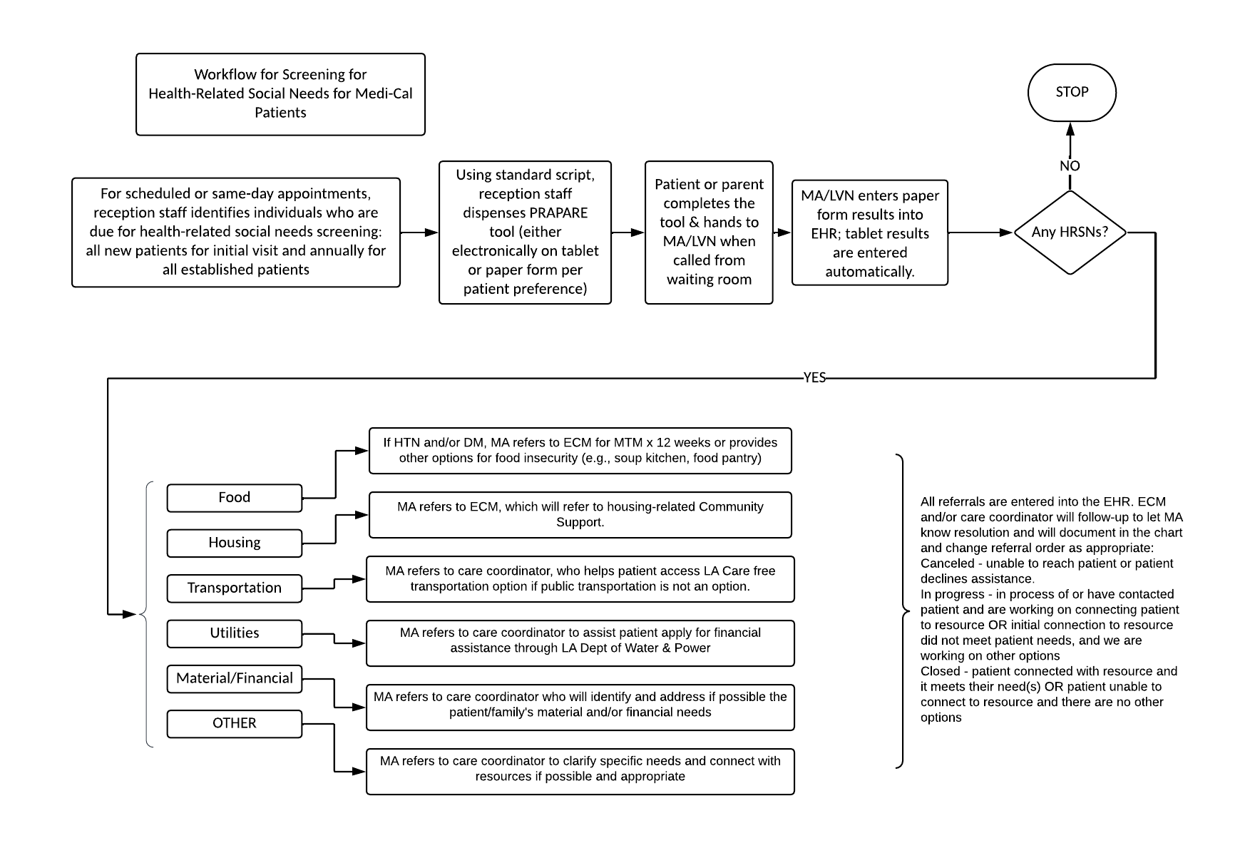

Therapeutic Inertia
The ADA makes a strong case to identify and address therapeutic (or clinical inertia) by prioritizing timely and appropriate intensification of lifestyle/behavior change (nutrition and physical activity) and/or pharmacologic therapy for patients who have not achieved the recommended metabolic goals (e.g., A1C, blood pressure, weight and LDL cholesterol). We deploy the following strategy to ensure none of our patients experience therapeutic inertia by our providers. [Insert chart review process. Consider reviewing the approaches and tools provided by the ADA’s Overcoming Therapeutic Inertia initiative.]

Before the Visit
Regardless of the reason for a visit, we identify and address preventive and chronic gaps in care for all patients through pre-visit planning and chart scrubs.
Insert the current process and/or workflow for pre-visit planning and chart scrubs, ensuring there are no missed opportunities (i.e., we saw the patient but neglected to identify and address gaps in care). Even if chart scrubs are done a day or two in advance, best practice is to ensure that gaps in care are identified and addressed for everyone, including same-day, walk-ins and virtual visits.

All adults with T2D should have standing orders for the following (at a minimum):
Refer to Table 4.1 Components of the comprehensive diabetes medical evaluation at initial, follow-up, and annual visits for additional standing order considerations.
- A1Cs – every three months if ≥ 7%, every six months if < 7%, or as per frequency determined by PCP
- Fasting lipid panel – 4-12 weeks after initiation or change in statin dose then annually
- Spot urinary albumin-to-creatinine ratio (uACR) annually
- Serum creatinine and estimated glomerular filtration rate (eGFR) annually
- Dilated eye exam annually
- Referrals for Diabetes Self-Management Education and Support (DSMES)

During the Visit
Recognizing that visit times may be too short to address patient-specific concerns as well to address every guideline and recommendation for adults with T2D, the following may be addressed over several visits or with others on our interprofessional care team to ensure that comprehensive guideline-concordant care is delivered.

Check Table 4.1 – Components of the comprehensive diabetes medical evaluation at initial, follow-up, and annual visits for the ADA recommendations for 2024.

For each of the components below, we follow the most current ADA Standards of Care.

- Blood pressure – measure at every routine clinical visit and treat to goal
- Bone health and fracture risk assessed in older adults with diabetes.
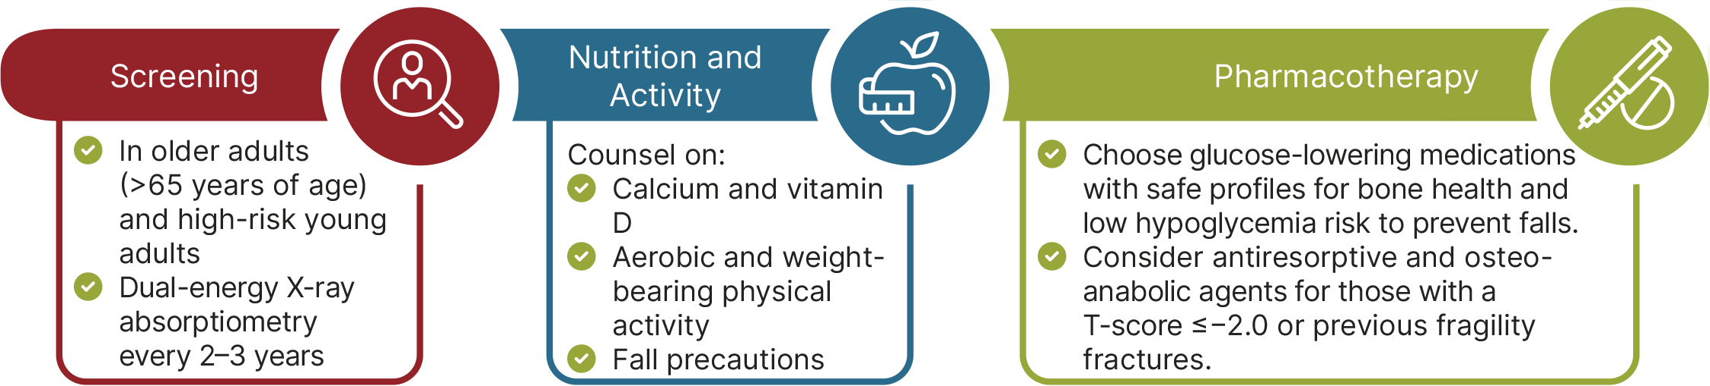

- Cancer - People with diabetes are at risk for several cancers and should be encouraged to complete recommended age- and sex-appropriate cancer screenings.
- Cardiovascular disease
- Cognitive impairment/dementia screening for early detection of mild cognitive impairment or dementia should be performed for adults 65 years of age or older at the initial visit, annually, and as appropriate. While the ADA does not recommend a specific screening tool for cognitive impairment but mentions the Mini-Mental State Examination, Mini-Cog, and the Montreal Cognitive Assessment.
- Dyslipidemia assessed and discussed with patient. (Below graphic from Lipid Management for Primary Prevention of Atherosclerotic Cardiovascular Disease (ASCVD) Events in People with Diabetes).

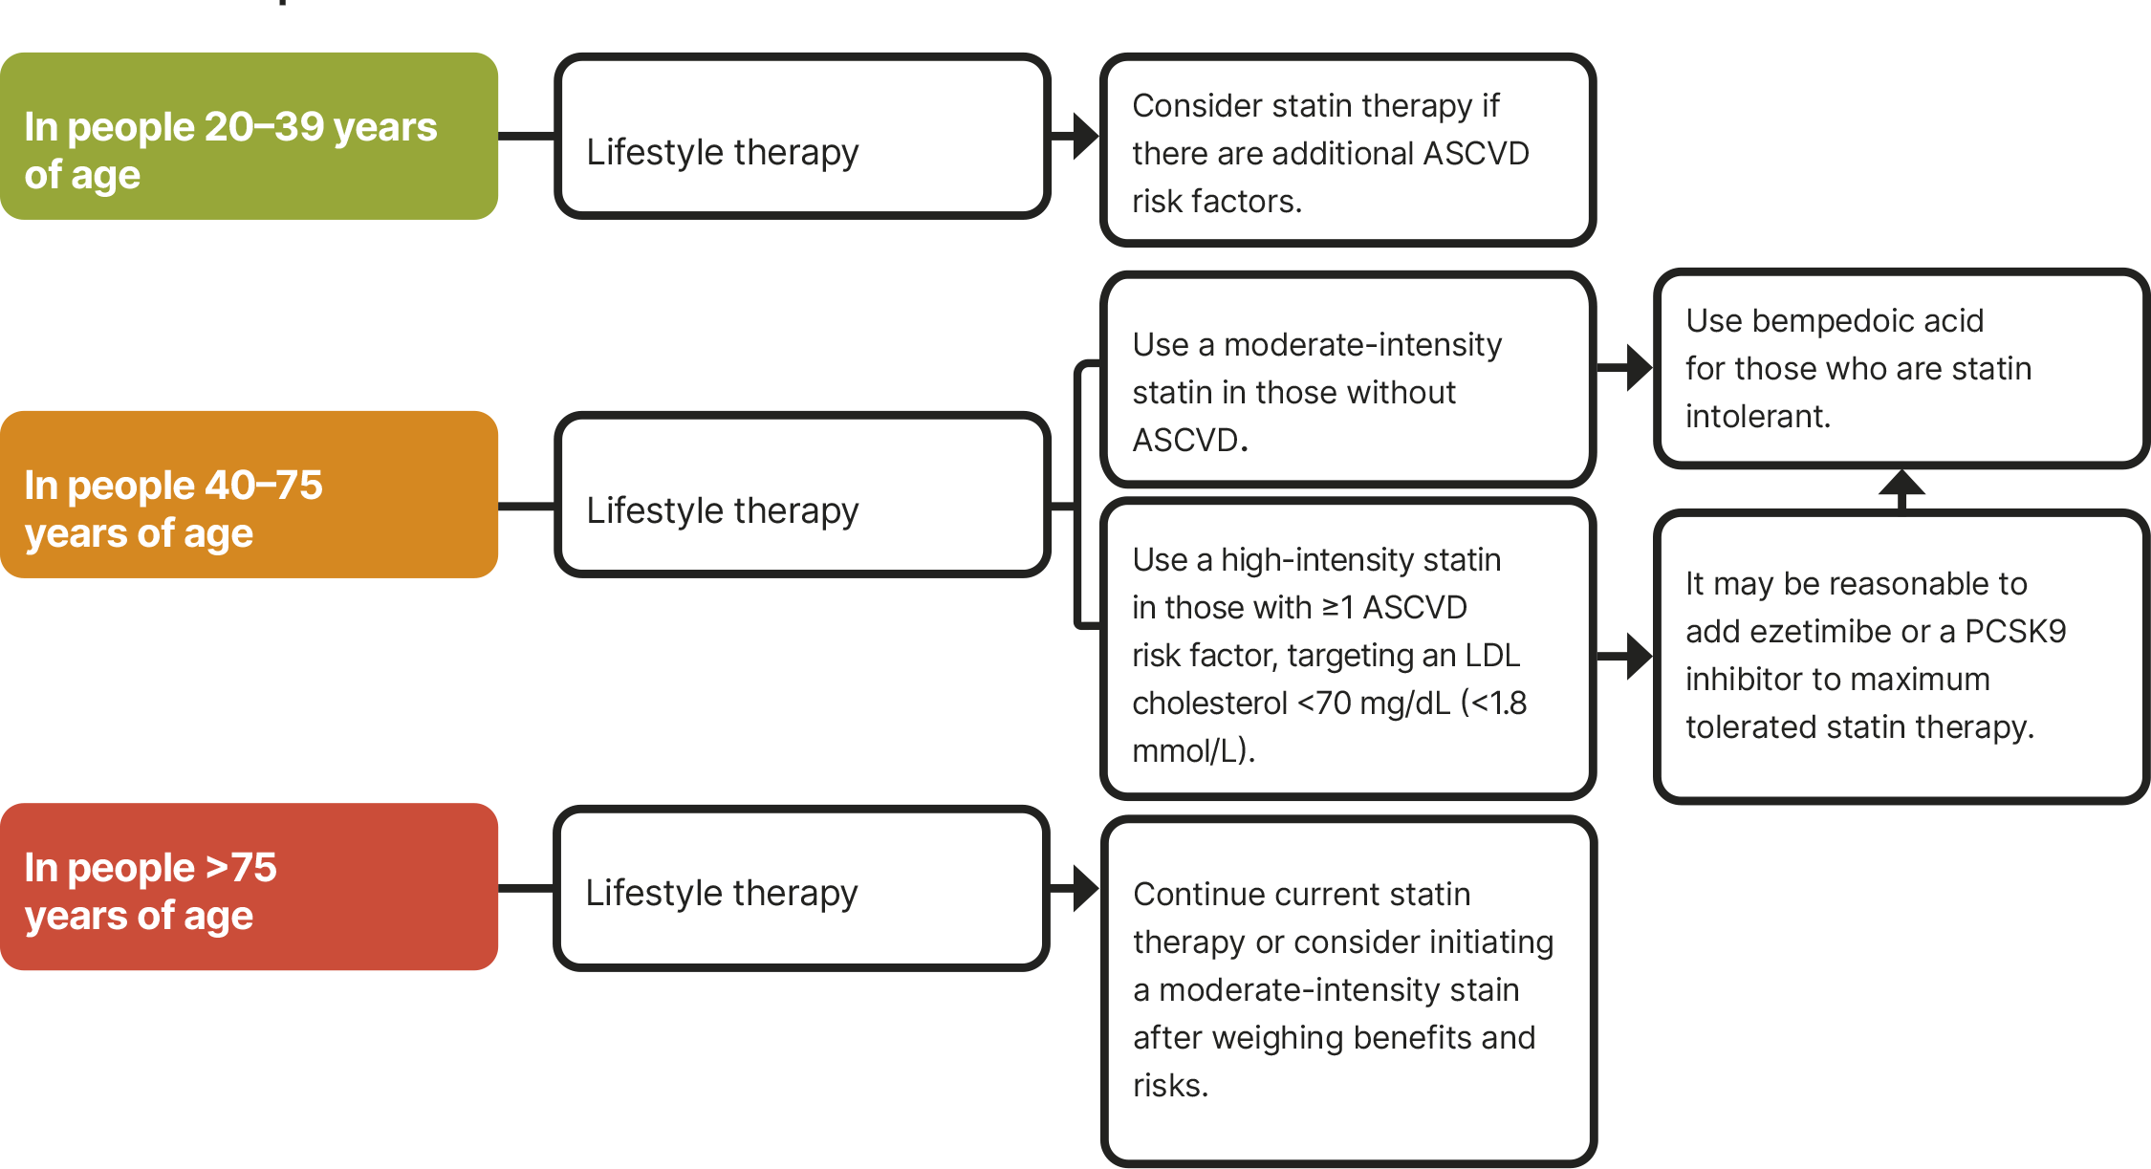

- Comprehensive foot assessment is performed annually by clinician and/or care team member to assess for neuropathy and other risk factors for ulcers and amputations, including assessment for peripheral arterial disease.
- Glycemic assessment and goals are discussed and agreed upon with patient and continuous glucose monitoring is considered.
- Health-related social needs are identified and addressed using the PRAPARE or another tool.
- Hypertension – blood pressure is obtained at every routine clinical visit, measured by a trained individual following guidelines (patient seated with feet on floor, arm supported at heart level after five minutes of rest with appropriate cuff size) with treatment to goal of < 130/80 unless otherwise determined by the treating clinician.
- Kidney function is assessed and discussed with patient; ICD codes entered/added to the problem list for any level of chronic kidney disease (CKD)
  - Stage 1 CKD (N18.1)- eGFR 90 or higher and kidney damage (e.g. uACR 30 or higher) for 3 months or more
  - Stage 2 CKD (N18.2)- eGFR 60-89 and kidney damage (e.g. uACR 30 or higher) for 3 months or more
  - Stage 3a CKD (N18.31) - Mild to moderate loss of kidney function (eGFR 45-59 for 3 months or more)
  - Stage 3b CKD (N18.32) - Moderate to severe loss of kidney function (eGFR 30-44 for 3 months or more)
  - Stage 4 CKD (N18.4) - Severe loss of kidney function (eGFR 15-29 for 3 months or more)
  - Stage 5 CKD (N18.5) Kidney failure (eGFR less than 15 for 3 months or more)
or on dialysis
  - End stage renal disease (N18.6)
- Medication reconciliation is performed at every visit for adults with T2D and includes assessing primary and secondary nonadherence and contributing factors (e.g., transportation, cost, side effects, lack of reminder systems).
- Mental health and well-being are assessed using standard assessment tools (e.g., Patient Health Questionnaire (PHQ-9) for depression or General Anxiety Disorder (GAD-7 for anxiety)
- Neuropathy assessment is performed at diagnosis of T2D and then annually.
- Nonalcoholic fatty liver disease and nonalcoholic steatohepatitis (NAFLD and NASH) screening/risk stratification should be administered for adults with T2D as per the current ADA recommendations.,
- Physical activity – all patients that can engage in physical activity are counseled about the risk of being sedentary and the goal of obtaining at least 150 minutes of physical activity per week.
- Retinopathy screening – all patients receive or are referred for dilated retinal exam at initial visit and annually thereafter.

Between Visits for all People with T2D
“Building positive health behaviors and maintaining psychological well-being are foundational for achieving diabetes management goals and maximizing quality of life.”

We conduct the following as needed to help people with diabetes achieve their health goals both during and between visits.
- Refer for diabetes self-management education and support.
- Refer for medical nutrition therapy (MNT).
- Counsel on routine physical activity.
- Counsel on and support cessation of tobacco products and vaping.
- Counsel and support health behaviors
- Support and refer to behavior health professionals for psychosocial care

All people with T2D are empaneled to a primary care provider and are risk stratified according to A1C values and other criteria, including but not limited to other comorbid conditions, health-related social needs, frailty, etc. Those with the highest risk are provided with enhanced services such as care management and care coordination.
The ADA states that DSMES is critical and that all people with diabetes should participate in DSMES.
All our patients with diabetes are strongly encouraged to participate in diabetes self-management education and support (DSMES) to facilitate informed decision-making, self-care behaviors, problem-solving, and active collaboration with the health care team.

Appropriate patients in need of care management, care coordination and/or care navigation are referred as per existing protocols.

Intensive lifestyle intervention programs and treatment / surgical options (as per primary care provider) are provided for obesity and weight management.
Telehealth and other virtual services are offered to expand access and accommodate patients’ preferences and needs.

Addressing Barriers to Adherence
Nonadherence to medication treatment plans has been called a public health issue and yet most primary care practices do not have a thoughtful, person-centered approach to identify and address this common problem faced by patients. Up to 25% of people with diabetes taking insulin report cost-related insulin underuse. Identify and address both primary and secondary nonadherence in the following ways:

Primary Nonadherence
Primary nonadherence occurs when a medication is prescribed for a patient, but the patient does not obtain the medication, or an appropriate alternative, within an acceptable period after it was prescribed. There are a variety of reasons why this can happen, and we strive to address the most common reasons.

Medication Cost
Whenever the information is available, our clinicians prescribe medications that are on patients’ insurance formularies by using the [insert any EHR features that assist with formularies and co-pay info]. or smart phone apps (e.g., ePocrates). For patients on Medi-Cal we prescribe medications that are on the Medi-Cal Rx Contract Drugs List and send those prescriptions only to pharmacies that work with Medi-Cal Rx. For patients without a prescription benefit, we use our internal dispensary.

For each medication on the patient’s list, enter the amount (if known) that the patient pays for each medication. Double-check with the patient to be sure that they can afford the medications we and others involved in their care are prescribing. If not, confer with the patient’s PCP.

Transportation
We identify and address transportation issues specific to patients’ ability to get to the pharmacy to pick up medications. If there are any issues, we work with the patient to find an affordable, acceptable option for transportation, including but not limited to managed care plan transportation assistance and the Medi-Cal Rx solution as well. “Members may also receive transportation services from PHC California to get to pharmacies. To learn more about transportation services, call Member Services at 1-800-XXX-XXXX (TTY 711).” Despite these options for transportation services, they are not always readily available or convenient for patients. For select patients we assist with mail order prescriptions, provided they have a stable living situation and mailing address and are able to pay online if needed for prescriptions.
Lack of Understanding the Reason/Importance
If a patient does not want to fill the prescription, we provide education on the importance of taking the medication.

Additional Considerations
We prescribe 90-day supplies when safe and appropriate to reduce the number of times that a patient needs to travel to a pharmacy to pick up medications.

Secondary Nonadherence
Recognizing that most people struggle to remember to take medications or even their daily vitamins every day, we simplify dosing regimens and work to help patients develop strategies to take their medications as prescribed.

Quality Improvement Strategy
Measures. We include the following measures to ensure high-quality healthcare delivery for our people with T2D and to identify opportunities to improve. These measures are obtained monthly, and each has an associated SMARTIE aim (specific, measurable, actionable, realistic, time-bound, inclusive and equity-based (or equitable)).

Measure (% means percent adults with T2D) | Outcome or Process | SMARTIE Aim (Y/N) | Frequency of Report
% with A1C > 9% | Outcome
% referred to or participating in DSMES | Process
% screened for health-related social needs | Process
% screened for behavioral health issues (e.g., depression, anxiety and/or diabetes stress) | Process
% screened for ACEs and toxic stress | Process
% with current A1C | Process
% screened for CKD with both UACR and eGFR | Process
% with CKD on SGLT2i in individuals with eGFR ≥20 mL/min/1.73 m² and urinary albumin ≥200 mg/g creatinine | Process
% on ACE-I or ARB for those with moderately increased UACR or severely increased UACR or eGFR < 60 | Process
% with screened for retinopathy every year (unless screening frequency is every 2 years, if appropriate) | Process
% with BP < 140/90 (or < 130/80) | Outcome
% with comprehensive foot exam, including screening for PAD and peripheral neuropathy | Process
% 40-75 years of age who have diabetes and who do not have clinical ASCVD, who received and adhered to statin therapy | Process
% with lipid panel in past 12 months | Process
% with no history of CVD with LDL < 100 mg/dL; and % with history of CVD with LDL < 70 mg/dL | Outcome
% with BMI ≥ 30 (consider % of those receiving high-frequency (≥ 16 sessions/6 months) counseling on nutrition changes, physical activity and behavioral strategies) and/or those on obesity pharmacotherapy) | Outcome (process for the other two)
% of visits in the visits in measurement period with A1C above goal for which there was an intensification of pharmacological therapy | Process
ACE – adverse childhood experiences; A1C – glycated hemoglobin; ARB – angiotensin receptor blocker; ASCVD – atherosclerotic cardiovascular disease; BP – blood pressure; BMI – body mass index; CKD – chronic kidney disease; CVD – cardiovascular disease; DSMES – diabetes self-management education and support; eGFR – estimated glomerular filtration rate; PAD – peripheral arterial disease; SGLT2i - sodium–glucose cotransporter 2 inhibitor; UACR – urine albumin-to-creatinine ratio

As part of our quality improvement strategy, we have the following in place.

Aim Statements
Create SMART(IE) aims for each measure to achieve within the next six-to-12-month timeframe (or other).

Tests of Change
List current or potential tests of change for each aim statement.

Method of Displaying and Sharing the Data
We run measures data monthly and review it during QI team meetings. [Insert process for sharing the data transparently with staff and the QI team; consider also sharing the data with patients (e.g., in the waiting room)].

Nundy S, Cooper LA, Mate KS. The Quintuple Aim for Health Care Improvement: A New Imperative to Advance Health Equity. JAMA. 2022;327(6):521–522.
Bodenheimer T, Sinsky C. From Triple to Quadruple Aim: Care of the Patient Requires Care of the Provider. Ann Fam Med. 2014;12(6): 573-6.
Overcoming Therapeutic Inertia. ADA. Therapeutic inertia as defined by the ADA is the “lack of timely adjustment to therapy when a patient’s treatment goals are not met”.
Successful Change Management Strategies for Improving Diabetes Care Delivery Among High-Performing Practices. Ann Fam Med. 2023.
Street Medicine Provider: Definitions and Participation in Managed Care. DHCS. 2022.
Section 10: Cardiovascular Disease and Risk Management. ADA Abridged Standards of Care 2024.
Section 10: Cardiovascular Disease and Risk Management. ADA Abridged Standards of Care 2024.
Older Adults: Standards of Care in Diabetes - 2024
NAFLD Prevalence, Who to Screen and How graphics. ADA Abridged Standards of Care 2024.
Nonalcoholic Fatty Liver Disease and Nonalcoholic Steatohepatitis. Comprehensive Medical Evaluation and Assessment of Comorbidities: Standards of Care in Diabetes-2024. ADA.
Section 5: Facilitating Positive Health Behaviors and Well-Being to Improve Health Outcomes. ADA Abridged Standards of Care 2024.
Herkert D, Vijayakumar P, Luo J, et al. Cost-Related Insulin Underuse Among Patients With Diabetes. JAMA Intern Med. 2019;179(1):112–114.
“For people with type 2 diabetes and CKD, use of an SGLT2 inhibitor is recommended to reduce CKD progression and cardiovascular events in individuals with eGFR ≥20 mL/min/1.73 m² and urinary albumin ranging from normal to 200 mg/g creatinine.” ADA Standards of Care in Diabetes – 2024 (p. S220).
“In nonpregnant people with diabetes and hypertension, either an ACE inhibitor or an angiotensin receptor blocker (ARB) is recommended for those with moderately increased albuminuria (UACR 30–299 mg/g creatinine) B and is strongly recommended for those with severely increased albuminuria (UACR ≥300 mg/g creatinine) and/or eGFR <60 mL/min/1.73 m² to prevent the progression of kidney disease and reduce cardiovascular events.” ADA Standards of Care in Diabetes – 2024 (p. S219).
“The on-treatment target blood pressure goal is <130/80 mmHg, if it can be safely attained.” ADA Standards of Care in Diabetes – 2024 (p. S181).

