You Just Turned 21!
It’s Time to Start Cervical Cancer Screening
What should I do now?
It’s time to start cervical cancer screening. For people with a cervix ages 21 to 29, cervical cancer screening is usually done with a Pap test every 3 years, as long as results are normal. Screening is recommended starting at age 21, no matter how old you were when you start having sex. Schedule your first Pap test today.

What happens during a Pap test?
A Pap test is done by a provider. The provider gently places a tool called a speculum into the vagina. The speculum moves the walls of the vagina apart so the provider can see the cervix. The provider then uses a small brush to gently collect cells from the cervix.
The exam may feel uncomfortable or strange, but it is brief. It should not be painful. Tell your provider if you are nervous, uncomfortable, or have concerns before the exam. They are used to talking about these topics and want to know how you feel. You are in control of your screening visit. You may:
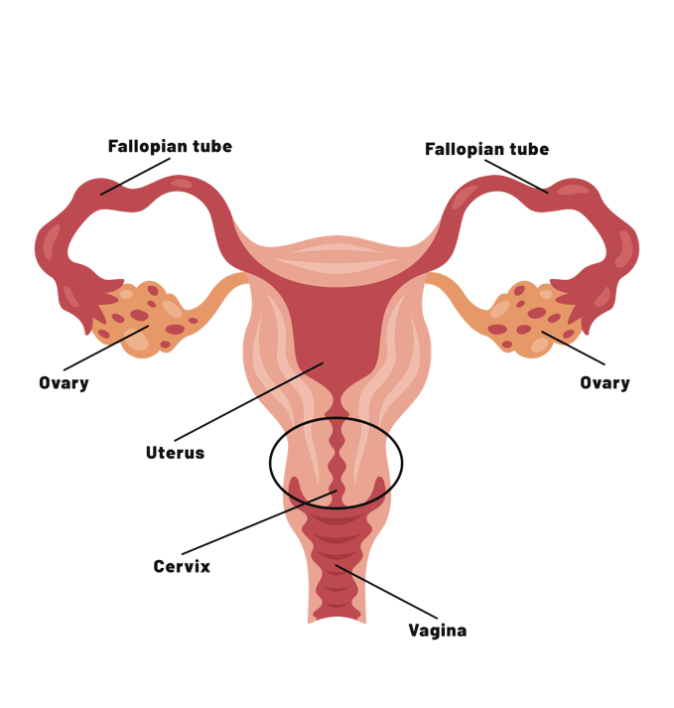
- Ask questions
- Request breaks
- Stop the exam at any time
Why does screening matter?
Cervical cancer screening checks for changes in the cervix. These changes can raise your risk for cervical cancer. These changes usually do not cause symptoms. Finding changes early can help prevent cervical cancer.
What is the cervix?
The cervix is the lower part of the uterus. It connects the uterus to the vagina.
What causes cervical cancer?
Almost all cervical cancers are caused by high-risk types of HPV, which stands for human papillomavirus. HPV is a virus that can spread through sexual activity and intimate skin-to-skin contact. You can get HPV from vaginal, anal, or oral sex with someone who has the virus, even if they do not have signs or symptoms. Not all HPV infections lead to cancer. Most go away on their own. Some types of HPV can also cause genital warts. HPV can also cause other cancers, including cancers of the penis, vulva, anus, and throat.

How can I lower my risk?
Did you know?
HPV is the most common sexually transmitted infection in the United States. Overall, HPV causes about 36,000 cases of cancer each year in the United States. About 40% of HPV-related cancers are in men.
Get the HPV vaccine
The HPV vaccine can prevent 90% of HPV-related cancers. It protects against the highest-risk types of HPV. The vaccine is recommended for children and adults ages 9-26.
Get screened
Cervical cancer usually takes years to develop. HPV can cause changes in the cells of the cervix. These changes are called precancerous changes which can be treated before progressing into cancer. A Pap test can help find these changes early. Screening and vaccination save lives.
Practice safer sex
Condoms and dental dams can lower the risk of HPV during sex. They do not give complete protection because HPV can affect areas not covered by condoms or dental dams. Limiting the number of sex partners can also lower your risk. However, even sex with one person can put you at risk.
Avoid smoking
Smoking does not cause HPV. But smoking can weaken your immune system and damage cells. This can make it harder for your body to clear HPV. Smoking is linked to a higher risk of cervical cancer and precancerous changes of the cervix.
What if my Pap test is abnormal?
An abnormal Pap test does not always mean cancer. Your provider will tell you what follow-up you need. In many cases, the Pap test can be repeated in one year because low-grade changes often go away on their own.
If the changes may be more serious, your provider may recommend a closer look at the cervix. This may include a biopsy. This procedure is called a colposcopy.
What else can I ask about?
Your visit is also a good time to talk about:
- HPV vaccine, if you did not get it when you were younger
- Pregnancy prevention, if you do not want to be pregnant now
- Other vaccines that can keep you healthy
- STI screening and prevention
- Diet, exercise, and weight management
- Family history of cancer, including breast and colon cancer
- Other chronic health conditions
You may need other screening or monitoring to stay healthy.
Schedule your appointment
To schedule cervical cancer screening, vaccinations, contraception, family planning, or a visit for other health concerns:

All appointments are confidential.

Reference: Screening for Cervical Cancer. Obstetrics & Gynecology 148(1):p e63-e67, July 2026. | DOI: 10.1097/AOG.0000000000006257

