Cervical Cancer Screening
What You Need to Know

Do I need cervical cancer screening?
If you have a cervix and are ages 21 to 65, you should be screened for cervical cancer. Screening is recommended no matter how old you were when you first started having sex. Cervical cancer screening checks for changes in the cervix and vagina. These changes may raise your risk for cervical cancer. If changes are found early, cervical cancer can often be prevented. Following screening guidelines can help you stay healthy.
What screening do I need?
Ages 21 to 29: Get a Pap test every 3 years, as long as results are normal.
Ages 30 to 65: Choose one of these screening options:
- HPV test every 5 years — preferred method
- HPV test and Pap test every 5 years
- Pap test every 3 years — least preferred method
What are my testing options?
Pap test
A Pap test is done by a provider. The provider gently places a tool called a speculum into the vagina. The speculum moves the walls of the vagina apart so the provider can see the cervix. The provider then uses a small brush to gently collect cells from the cervix.
What should I expect during a Pap test?
The exam may feel uncomfortable or strange, but it is brief. It should not be painful.
Tell your provider if you are nervous, uncomfortable, or have concerns before the exam. They are used to talking about these topics and want to know how you feel.
You are in control of your screening visit. You may:
- Ask questions
- Request breaks
- Stop the exam at any time
HPV test
For people with a cervix ages 30 to 65, an HPV test is recommended every 5 years.
An HPV test can be done in two ways:
- A provider collects cells from the cervix during a pelvic exam with a speculum. If HPV is found, the same sample can be checked for precancerous changes.
OR
- You collect cells from the vagina using a soft swab. This can be done in private at the medical office, lab, or at home. Self-collection only tests for HPV. If the HPV test is abnormal, you will need to come back for more testing of the cervix.
Both methods are effective.

Ask about HPV self-collection
Some patients prefer self-collection because it offers more privacy and avoids a speculum exam. Most patients who use self-collection will not need to come back for more testing. However, if the HPV test is abnormal, follow-up care will require a pelvic exam. Ask your care team if self-collection is right for you.
Who should not do HPV self-collection?
HPV self-collection may not be right for:
- People who prefer their provider to do the test
- People who have abnormal vaginal bleeding or pain
- People who are pregnant or gave birth in the last 3 months
- People who are on their period or had period bleeding in the last 48 hours
- People who used products inside the vagina in the last 72 hours, such as
creams, washes, vaginal contraceptives, or condoms
- People who had sex, a vaginal exam, or a vaginal ultrasound in the last 48 hours
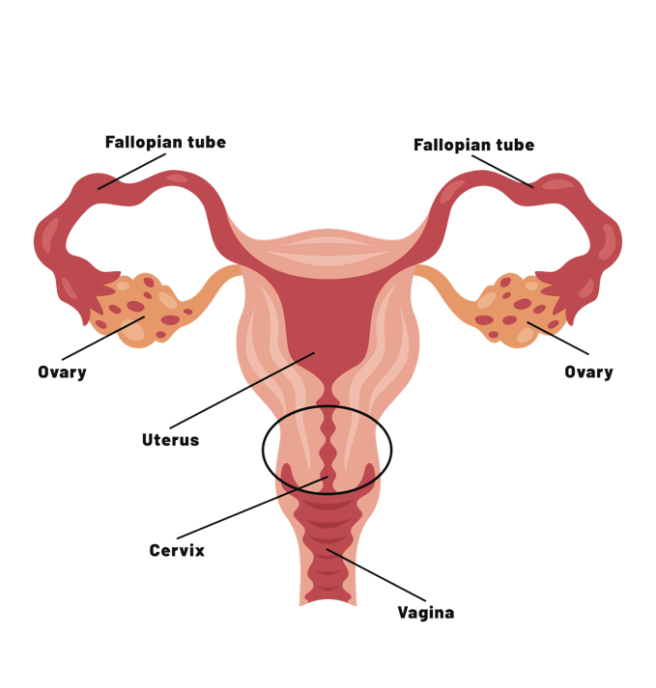
- People younger than 30
What is the cervix?
The cervix is the lower part of the uterus. It connects the uterus to the vagina.
What causes cervical cancer?
Almost all cervical cancers are caused by high-risk types of HPV, which stands for human papillomavirus. HPV is a virus that can spread through sexual activity and intimate skin-to-skin contact. You can get HPV from vaginal, anal, or oral sex with someone who has the virus, even if they do not have signs or symptoms. Not all HPV infections lead to cancer. Many go away on their own. HPV can also cause genital warts. HPV can also cause other cancers, including cancers of the penis, vulva, anus, and head and neck.
What happens if my test is abnormal?
An abnormal test does not always mean cancer. If you did a self-collected HPV test, you will need to come back for more testing. This will require a pelvic exam by your provider. If your provider collected your Pap test or HPV test, your follow-up will depend on your results.
- In many cases, the test can be repeated in 1 year. Low-grade changes often go away on their own.
- If the changes are mild, it may be safe to wait and see if they go away. These changes usually take years to get worse.
- If the changes may be more serious, or if there are cervical cell changes plus an HPV infection, your provider may recommend a closer look at the cervix. This may include a biopsy. This procedure is called a colposcopy.
Your provider will tell you what follow-up you need based on your results, age, and risk factors.

How can I lower my risk?
Did you know?
HPV is the most common sexually transmitted infection in the United States. Overall, HPV causes about 36,000 cases of cancer each year in the United States. About 40% of HPV-related cancers are in men.
You can lower your risk in several ways.
Get the HPV vaccine. The HPV vaccine can prevent 90% of HPV-related cancers. It protects against the highest-risk types of HPV. The vaccine is recommended for children and adults ages 9-26. It may be appropriate later in life after talking with your provider.
Get screened. Cervical cancer usually takes years to develop. HPV can cause changes in the cells of the cervix. These changes are called precancerous changes. In some cases, they can slowly turn into cancer if they are not followed or treated. These cell changes usually do not cause symptoms. A Pap test or HPV test can help find them. Cervical cancer screening and the HPV vaccine have greatly lowered the number of cervical cancers and precancerous changes in the United States. Screening and vaccination save lives.
Practice safer sex. Condoms and dental dams can lower the risk of HPV during sex. They do not give complete protection because HPV can affect areas not covered by condoms or dental dams. Limiting the number of sex partners can also lower your risk. However, even sex with one person can put you at risk.
Avoid smoking. Smoking does not cause HPV. But smoking can weaken your immune system and damage cells. This can make it harder for your body to clear HPV. Smoking is linked to a higher risk of cervical cancer and precancerous changes of the cervix.
What else can I talk about with my provider?
Your visit is also a good time to talk about:
- HPV vaccine, if you did not get it when you were younger
- Pregnancy prevention, if you do not want to be pregnant now
- Other vaccines that can keep you healthy
- STI screening and prevention
- Diet, exercise, and weight management
- Other recommended cancer screening tests
- Family history of cancer, including breast and colon cancer
- Other chronic health conditions
You may need other screening or monitoring to stay healthy.
Schedule your appointment
To schedule cervical cancer screening, vaccinations, contraception, family planning, or a visit for other health concerns:

All appointments are confidential.

Reference: Screening for Cervical Cancer. Obstetrics & Gynecology 148(1):p e63-e67, July 2026. | DOI: 10.1097/AOG.0000000000006257

